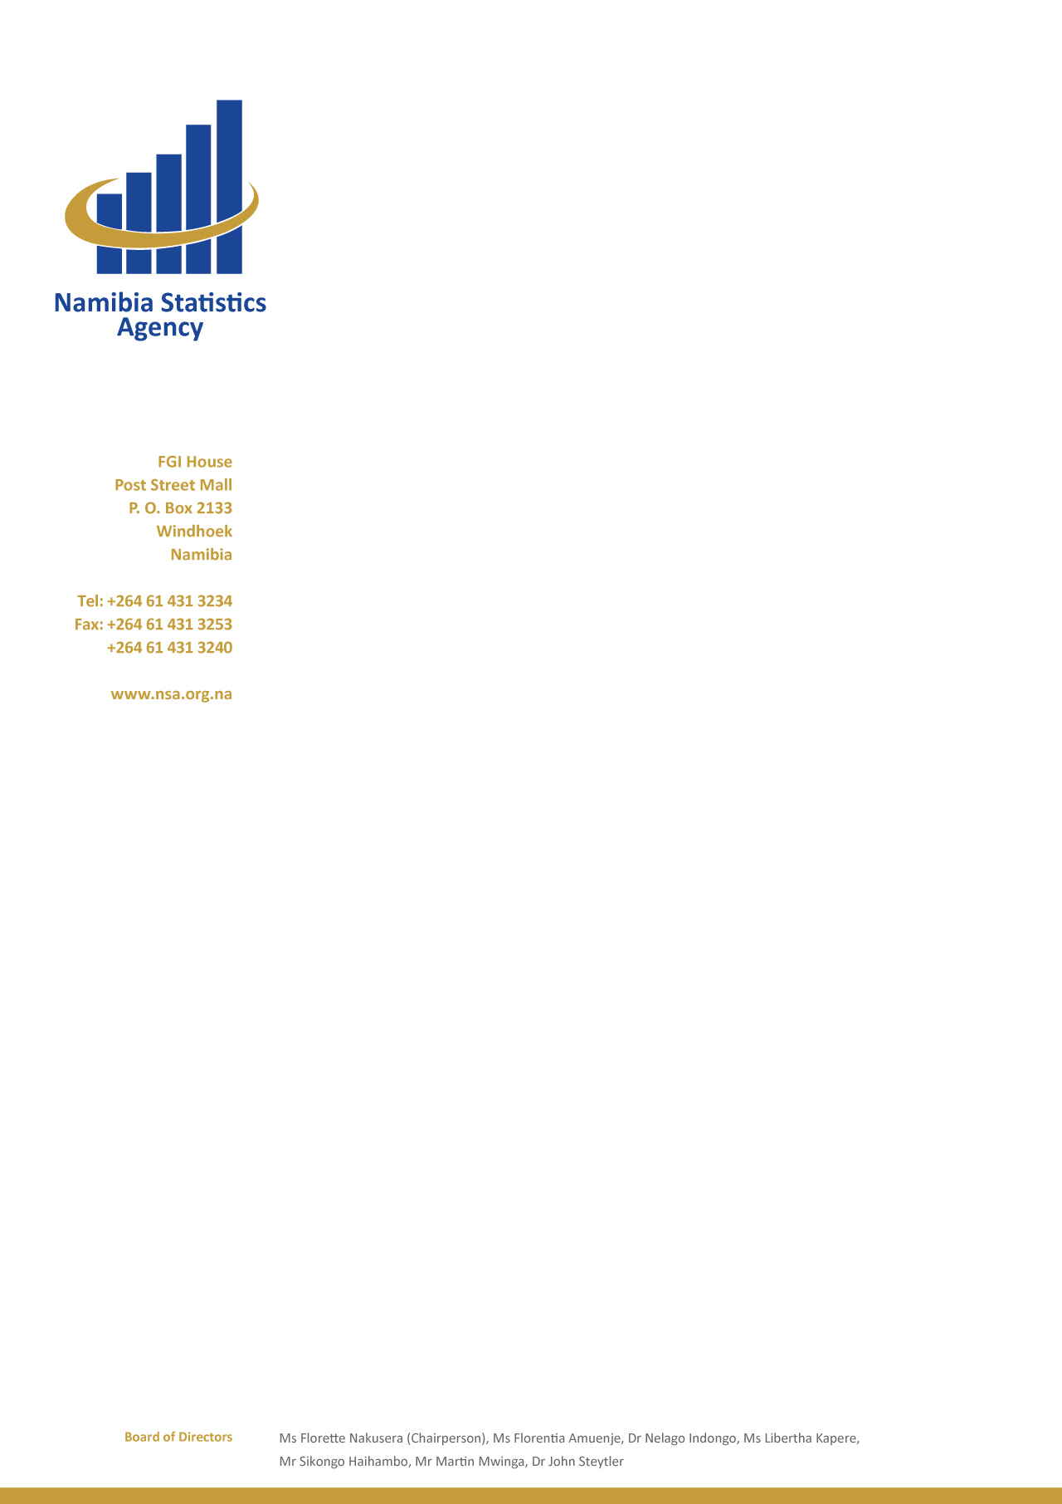

PRESS STATEMENT

MR. SIKONGO HAIHAMBO
ACTING STATISTICIAN GENERAL: NAMIBIA STATISTICS AGENCY
Windhoek – 09 September 2015

- The Namibia Statistics Agency is pleased to present the economic developments for 2014 following the preliminary results during March 2015. Before I elaborate on the results of 2014, let me first say few words about the revision policy as per the compilation of the national accounts. National accounts revision are informed by updated information received from data sources after release of a Publication.

- Under normal circumstance, that is all things being equal, revisions in the national accounts affect the last three years.

- Apart from such standard revisions, national accounts did a system audit which involved updating the entire compilation system of national accounts and hence minor revisions can be seen as far back as 2008.

- Reflecting on economic developments, Namibia has embarked on a lot of developmental projects such as the TIPEEG, Mass housing and the NDP IV projects to mention a few. These development projects are aimed at accelerating economic growth and thereby creating employment.

- With reference to the economic performance of 2014, the Namibian economy performed exceptionally well, recording an exceptional growth of 6.4 per cent when compared to 5.7 per cent registered in 2013.

- The performance in 2014 was led by the increase in growth in the construction sector with 40.5 per cent, wholesale and retail trade sector that posted a growth of 15.2 per cent and agriculture sector that recorded an increase of 9.6 per cent.

- The robust performance in the construction sector is mainly due to the construction work in the mining sector and construction works for general government that recorded a notable 100.9 per cent and 35.3 per cent, respectively.

- The growth in agriculture was driven by the livestock subsector that increased by 13.0 per cent in real value added. The increase is due to restocking and re-investment in livestock by farmers after the drought in 2013 and the good rainfall received during 2014, while crop farming grew by 5.3 per cent in real value added.

- The expansion in wholesale and retail trade is attributed to high sales activities in wholesale and vehicle subsectors that increased by 32.6 per cent and 7.0 per cent in respectively, in 2014.

- Moreover, other sectors that performed relatively well were: utility (4.9 per cent), transport and communication (6.6 per cent), hotels and restaurants (5.3 per cent).

- The utility sector posted a positive growth of 4.9 per cent in real value added; this growth is driven by the electricity subsector that increased by 7.3 per cent due to sales of electricity to the mining sector, which grew by 110.3 per cent. Unfortunately, the water subsector contracted by 2.9 per cent during the period under review.

- Although the total economy posted a strong growth in 2014 when compared to the previous year of 2013 some sectors like mining, fishing and fish processing on board and manufacturing performed poorly, showing a contraction of 6.3 per cent, 2.5 per cent and 2.2 per cent respectively.

- The mining sector’s poor performance was influenced by low production activities in uranium which declined by 9.9 per cent and other mining and quarrying with a negative growth of 39.7 per cent. The drop in production of uranium was due to lower demand of the commodity by the international markets.

- In conclusion, NSA would like to thank our data source providers and to encourage others data sources to responds to our annual economic surveys which can greatly enhance the accuracy of measurement of the GDP growth of the country.

