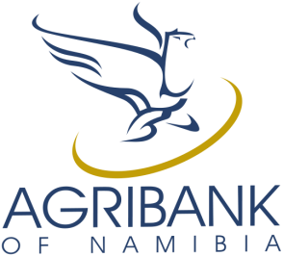

MEDIA RELEASE

We are ready to listen to our individual clients

05 May 2017

FOR IMMEDIATE RELEASE

Agribank chief executive officer, Sakaria Nghikembua, has assured the Namibia National Farmers Union (NNFU) that the bank is ready to listen to individual clients who are prepared to engage it in order to make arrangements to repay their debts. Nghikembua stated that the bank has always been ready and continues to listen to numerous clients who visit Agribank on a daily basis to discuss their challenges with a view to enter into credible, fair and practical arrangements to settle their outstanding arrears. “Every client has a unique situation and we cannot, as a bank, discuss individual clients’ situations in a group. We are glad that a number of our clients have already visited our offices or those of our appointed debt collectors, in this regard. We have a responsibility to ensure that the bank is financially sustainable and the debt collections initiative is just but one initiative that the bank is implementing in pursuit of the financial sustainability objective.”

The Agribank chief made the remarks at a stakeholder engagement session with NNFU, which represents communal farmers throughout the country. The objective of the engagement session was, amongst others, to share the key milestones achieved by the bank over the past nine months, highlights of the Bank’s 5-year strategy and its focus for the future.

At the occasion, NNFU Board member and Councillor of the Aminuis Constituency, Peter Kazongominja, expressed satisfaction with the information presented at the session, which contextualizes the bank’s strategy and the rationale for the arrears collection initiative. According to him, many farmers are battling with the effects of the recent drought and low livestock levels. As a result, some farmers adopted an antagonistic attitude towards the bank but he assured the Agribank team that NNFU will continue to spread the message to its members. “I can assure you that my message to our members will be to urge them to visit Agribank offices as individual clients to make suitable arrangements since clients are individually liable to settle their outstanding debts,” he stated.

On his part, NNFU Executive Director, Mwilima Mushokabanji, reiterated that lack of information by communal farmers sometimes lead to anger and frustrations, but that once the relevant information is shared, the farmers understand and appreciate the context of decisions affecting them.

Mushokabanji invited the bank to attend its annual congresses as well as regional farmers' information days to share information about its operations and activities. He further applauded Agribank for introducing the no collateral loan product for communal farmers, stating that it is long overdue and a huge boost for communal farmers in the country.

NNFU was represented by its Executive Director, Executive Board Members Sirkka Iileka and Kazongominja as well as Beata Xulu, the NNFU’s Program Manager.

End.

