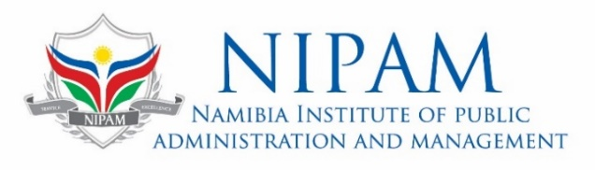

27 Paul Nash Street, Olympia
Private Bag 13218 Windhoek
Tel +264 61 2964700
Fax +264 61 2964830

REF: 4/6/2

Cafeteria Catering Booking Form

Section A: Customer Details

Booking Date:
Organisation:
Contact/Organiser:
Organisation Finance Contact:
Contact Nr. & email of Finance Person:
Postal Address:
Physical Address:
Tel Nr.: | +264 |  |  |  |  |  | Cel Nr.: | +264
Email:

Section B: Function/Training/Conference Details

Event Title:
Conference Room: |  |  |  |  |  |  |  |  | Nr. of Attendees
Duration: | from |  |  |  |  |  | to |  |  | Nr. of Days
Daily Start and End Time: |  |  |  | from |  |  |  | to

Section C: Refreshments - Timing and Arrangements

Options: | Welcoming Tea |  | AM tea |  | Lunch (Buffet |  | PM Tea

Services are provided at these hours: Welcoming tea/Coffee at 08h00, AM tea/coffee at 10h00, Lunch (Buffet) at 13h00, and PM tea at 15h00.

Please indicate the number of drinks to be served to each attendee per day:

Water 500ml |  | Cooldrink 300ml |  | Juice 300ml

PLEASE INDICATE THE TYPE AND NUMBER OF SPECIAL MEALS REQUIRED:

Diabetic |  | Vegetarian |  | Halaal

Other specifications: ..…………………………………………………………………………………………
…………………………………………………………………………………………………………………..
…………………………………………………………………………………………………………………..
……………………………………………………………………………….................................................

STANDARD TERMS AND CONDITIONS:
- Written confirmation and acceptance of the quotation, along with the order or Proof Of Payment, must be sent to cafeteria@nipam.na and finance@nipam.na at least five (5) working days before the function/conference date.
- Booking must be sent via email to cafeteria@nipam.na. and finance@nipam.na. Telephone Number: +264 61 296 4800
- Should the quoted organisation not have approved credit facilities with NIPAM, 100% payment will be required before any services can be rendered. Customers with a credit facility must settle all invoices within 15 days of the event, and thereafter, interest at 2.5% will be charged on accounts 30 days overdue.
- By accepting the provided quotation, the customer/organisation agrees with the terms and conditions, and any subsequent cancellation or reduction in attendance must be communicated in writing, subject to the following cancellation/reduction penalties:
  - Cancellation or reduction received five (5) working days before the event – No cancellation fees.
  - Cancellation or reduction received one (1) working day before the event – 50% of the quotation amount will be paid.
  - Cancellation or reduction received on the event date – 100% of the quotation amount will be fully paid.
- The final invoice, including all charges, will be issued on or after the event date.
- Catering services are limited to the menus attached hereto. Special menus can be arranged in advance of the event.
- Any special requests made on the day of the event will be considered, if possible, but an additional fee of N$1,500.00 will be added to the account.

I (Insert full name), Owner/representative

of (Insert full name of company)

I hereby undertake in writing that my company will at all relevant times fully comply with the above terms and conditions.

I am fully aware that failure to comply with these terms and conditions shall result in the actions stipulated above.

Signature: ……………………………….............Date: ……………………………… Seal/Stamp:

